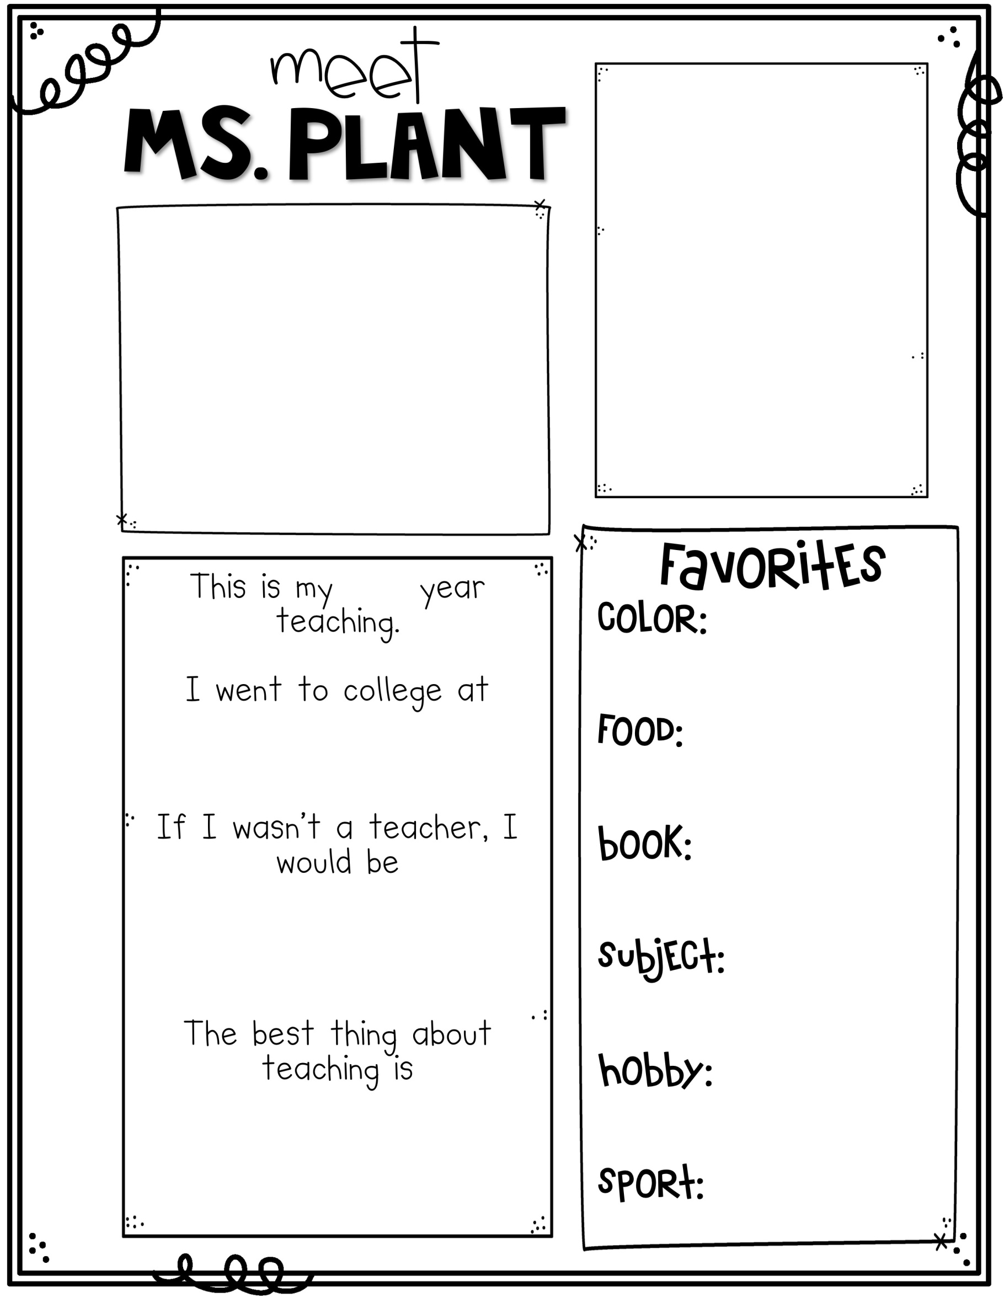1893

Mrs. Lanich

**Teachers who love teaching teach children to love learning!**

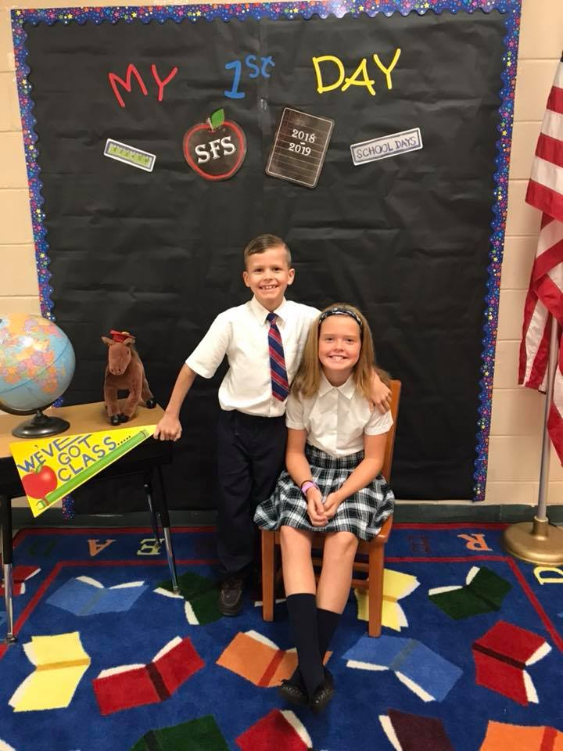

**13th**

**Purple & Blue**

**Chocolate & Pizza**

**Clarion University &**

**Lock Haven University**

**The Hunger Games**

**An event planner living at the beach!!!**

**Math**

1

**Building relationships with my kids and watching them learn and grow as great little people. They make me laugh every day!!**

**Gardening and Baking**

**Soccer**